Workrite Sierra HX Bi Level Electric Height Adjustable Table

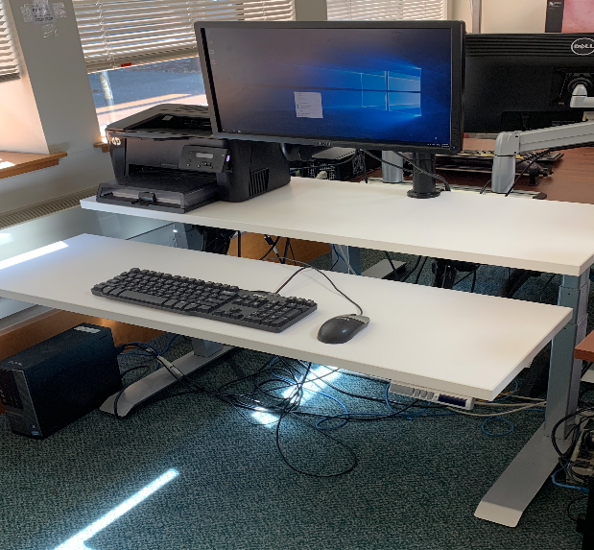
Price is $1,186.38. #SEHX-CWC-46325B-S-0D-1 Prices includes delivery but not tax. Please call 877-722-9090 for showroom appointment to see the table. The Workrite Bi-Level table includes:

- A rear height range 22.5-48 inches
- Independent height/tilt adjustable keyboard platform with 6 inch up/down height adjustment
- Pre-set activation buttons for easy adjustment
- 220 pound capacity

How to order through BearBuy:
- Go to https://blu.berkeley.edu (CalNet ID and password)
- Click “Buying” tab at the top left bar
- Click “BearBuy on the left side bar
- Click the One Workplace site under the punch out section
- Click “UCB Ergo Matching Funds Program” on left hand side bar to select table model and options

Table Options:

- Sizes:
31’’ deep x 46’’ wide (15’’ front/16’’rear depth)

- Finishes:

  - Laminate Top:_______________________
    - 24 options in available in Bear Buy catalog

  - Base: Silver

