Tips for Sitting and Standing at the Computer
Using a fully height adjustable workstation allows for safe working postures in both sitting and standing positions. Research findings recommend: Sit for 20, Stand for 8 and Move for 2 minutes per half hour. These workstations promote postural changes throughout the work day and have positive ergonomic and health benefits. This tip sheet provides basic set up and work flow practices to assist the computer user in safely using a sit-and-stand workstation. With any workstation set up, take movement breaks every hour and change your postures when you start to fatigue.

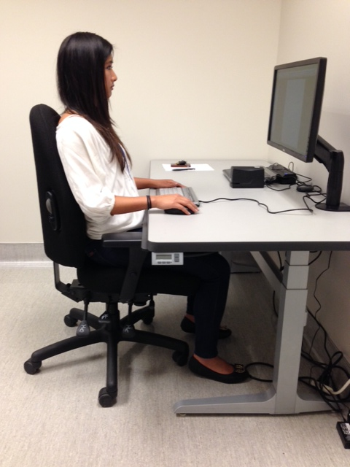 |  | 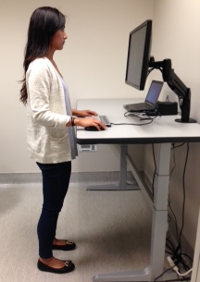

Sitting Posture
Sitting Posture | 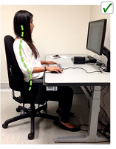 | 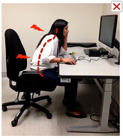
- Feet flat on the floor or footrest
- Majority of thighs supported
- Lower and upper back well supported
- Relaxed shoulders and arms
- Elbow close to side of the body
- Input devices at elbow height
- Eyes near top of the screen
- Stand when you start to feel restless

Standing Posture
Standing Posture | 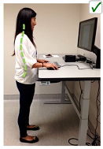 | 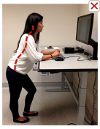
- Good foot support (low heeled supportive shoes or insoles)
- Knees slightly bent (no locking)
- Shift weight, change leg position often
- Elbows close to the body
- Input devices at elbow level
- Eyes at top of the screen
- Sit down when you start to feel fatigued

Work Flow: The Next Posture is the Best Posture
Work Flow: The Next Posture is the Best Posture |  | 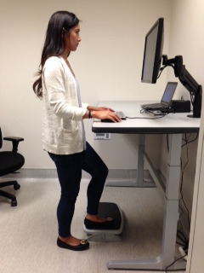
- Your body is designed to move throughout the day. Standing or sitting in any one position for long periods has health disadvantages
- Listen to your body; change postures when you fatigue or start to slouch or slump forward
- Start by standing for short periods (5-10 minutes every hour)
- Increase standing gradually based on your comfort level and individual limits. Research findings recommend: Sit for 20, Stand for 8 and Move for 2 minutes per half hour.
- Once you get acclimated, try switching between standing and sitting more frequently, e.g., every 20-30 minutes

Resources for Computer Users
Be Well at Work- Ergonomics Website:
http://www.uhs.berkeley.edu/ergonomics/
How to Set Up a User-Friendly Workstation: https://uhs.berkeley.edu/sites/default/files/workstation.pdf
Workstation Furniture (Adjustable tables, Chairs & Keyboard Trays):
Call UC Furniture Services toll-free at (877) 722-9090 for an appointment at the campus showroom
Workshops for Faculty and Staff:
Computer Health Matters workshop on workstation setup and stretches. Enroll online https://uhs.berkeley.edu/facstaff/ergonomics/classes-workshops
Stretch Break Software:
Use your Cal Net ID to download software that reminds you to take breaks. Go to blu.berkeley.edu, chose the People tab, Job Tool section. Put in an IT help desk request if you don’t have administrative rights.
Movement Breaks:
See the Move “50 tips to move more at work” for ideas on how you can increase movement
Medical Appointments:
Call the Occupational Health Clinic for work-related injuries at (510) 642-6891






