Back Talk

For UC Berkeley Faculty and Staff

Basic Stretching and Strengthening Program:

The following suggestions of exercises are to maintain and/or improve flexibility and strength of low back and legs.

It is recommended to:
- Warm–up before doing these exercises with some kind of general activity, such as walking or biking.

- Perform these suggested exercises on a daily basis. The whole program takes about 30-40 minutes. It is recommended to do these exercises on a softer surface, such as carpet or a Yoga mat.

- Be gentle with the stretching exercises. Only a mild stretching sensation should be felt without tingling or numbness into the calf or feet. Do not bounce into any stretches.

- If you are unable to maintain a position with good form, reduce the amount of time you hold to 5-15 seconds, or return to the first exercise in a progression.

- These exercises should never cause pain.

- Hold stretches from 5-15 seconds up to 1 minute (as tolerated) and repeat 3-5 times.

- Remember to breathe during the exercises. It might help to count out loud to avoid holding your breath.

Stop the exercise immediately if pain or discomfort is perceived. Do not overextend or attempt to do too much. Consult a medical professional if pain persists.

This handout is in conjunction with a video for you to follow which is available at: https://www.youtube.com/watch?v=wbucdcsORrE

Stretches

Starting position: Laying on back with feet on the floor in neutral spine = low back relaxed and almost flat (no arch or excessive rounding), ribcage level

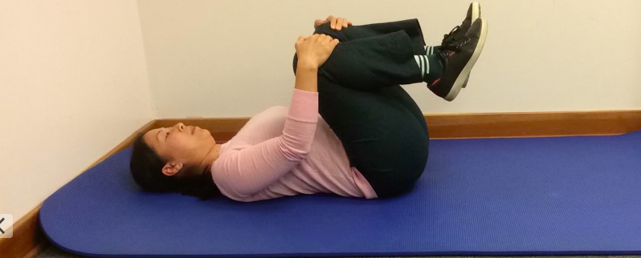 | Double Knees to Chest  Starting position: On back with feet on floor  Movement: Bring one knee up and then the other. Gently pull both towards your chest - feel a mild stretch in lower back  Dosage: hold 5-15 seconds, repeat 3-5 times
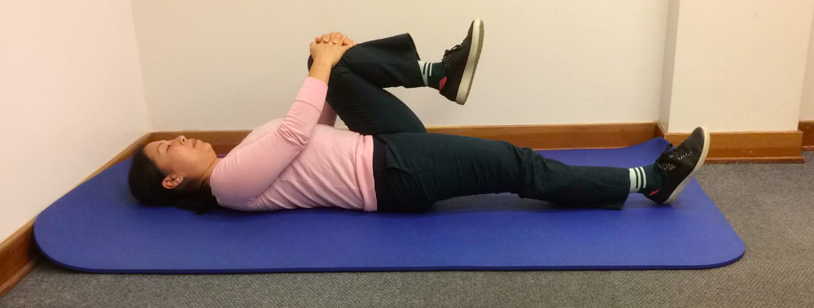 | Single Knee to Chest with Heel Slide  Starting position: On back with feet on floor  Movement: Bring one knee towards chest and hold while sliding the other leg straight  Dosage: Hold 5-15 seconds, repeat 3-5 times each leg
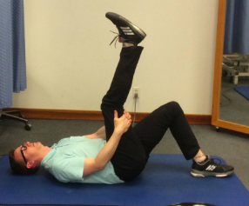 | Hamstring Stretch  Starting position: On back with feet on floor  Movement: Bring one knee towards chest and hold behind thigh. Slowly straighten knee until you feel a mild stretch in the back of the thigh.  Dosage: Hold 5-15 seconds, repeat 3-5 times each leg
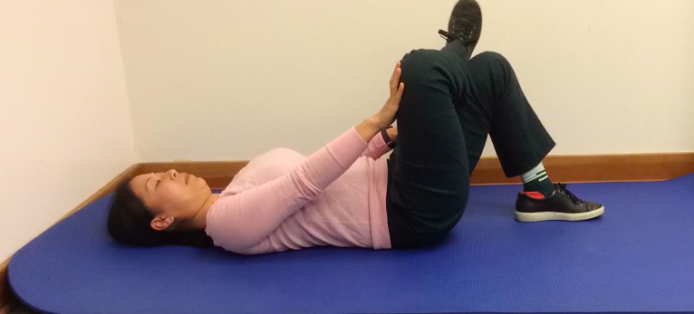 | Buttocks /Hip Stretch  Starting position: On back with one foot rested on the opposite knee. See photo.  Movement: Push the knee of the top leg away until you feel a stretch in the buttocks  Dosage: Hold 5-15 seconds, repeat 3-5 times each leg

Trunk Stability

Starting position: Laying on back with feet on the floor in neutral spine = low back relaxed and almost flat (no arch or excessive rounding), ribcage level

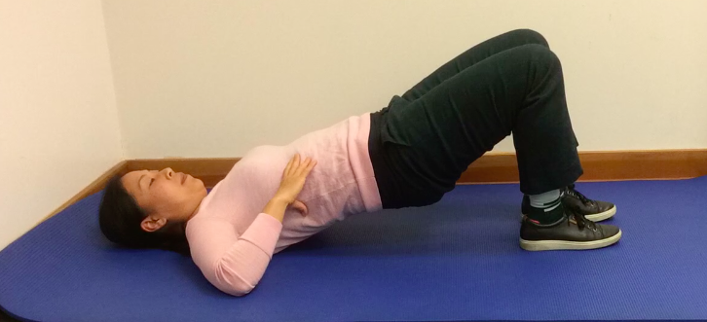 | Bridge  Starting position: On back with feet on floor  Movement: Keeping abdominals tight, slowly raise buttocks from floor moving at hips. Keep pelvis level and do not let hip drop on one side.  Dosage: Hold 5-15 seconds, repeat 3-5 times
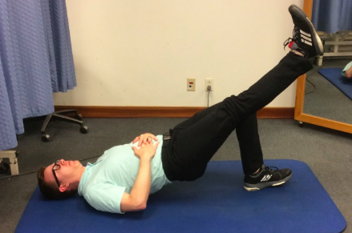 | Bridge with Straight Leg (Progression)  Starting position: On back with feet on floor  Movement: Start with a bridge position (see above). Slowly straighten leg while maintaining level pelvis.  Dosage: Hold 5-15 seconds, repeat 3-5 times each leg
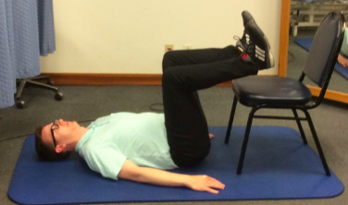 | Abdominal Bracing and Strengthening  Starting position: On back with feet on floor or legs on chair  Movement: Lift one knee towards ceiling, slowly do the same with the other knee and maintain tabletop position (see picture). Make sure your spine is flat into the floor and the ribcage is not elevated. Starting position can also be with both feet resting on a chair.  Breathe! If this is too difficult, start with holding one leg up at a time in this position and progress to holding both legs up.  Dosage: Hold 5-15 seconds, repeat 3-5 times each leg
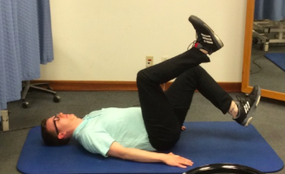 | Heel Taps (Progression)  Starting position: Tabletop (see picture above left)  Movement: While maintaining neutral spine, slowly bring the heel of one leg towards the floor and lift back up to tabletop position. Go only as far as you can control.  Dosage: Hold 5-15 seconds, repeat 3-5 times each leg

Exercises on Hands and Knees

Starting position:
- Place hands under shoulders and knees under hips.
- Engage abdominals, lift belly button and maintain a straight (neutral) spine.
- Look between your hands and lift back of head towards ceiling.

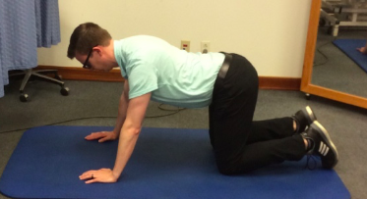 | Cat/Camel  Movement: From the neutral position, slowly round your spine, hold for 15 seconds, then slowly drop your spine (belly button) towards the floor (as shown in picture)  Dosage: Hold position for 5-15 seconds, repeat 3-5 times each direction and finish with your spine in neutral position
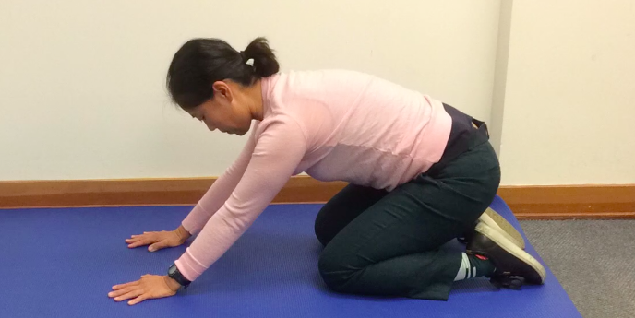 | Sit Back Rock  Movement: In neutral spine, place knees slightly apart. While maintaining your spine in a neutral position, rock towards your heels. Keep hands placed in original position. Rock back to neutral.  Dosage: Hold position for 5-15 seconds, repeat 3-5 times
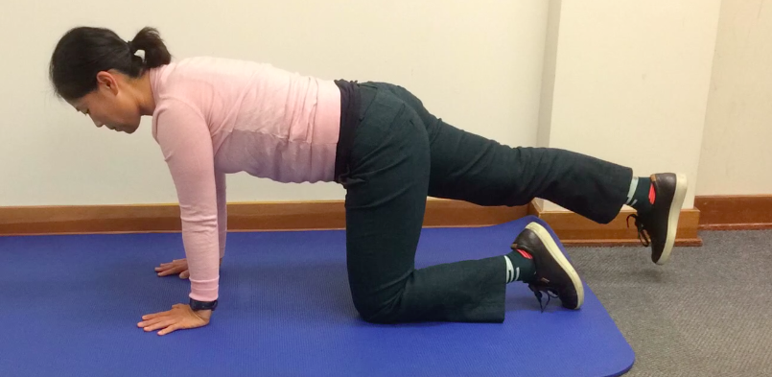 | Trunk Stability  Movement: Slowly straighten one leg and lift 2-3 inches off the floor. Maintain spine and the pelvis level and do not twist in spine. Do not arch back. Bring leg back to quadruped and repeat with other leg.  Dosage: Hold position for 5-15 seconds, repeat 3-5 times each leg
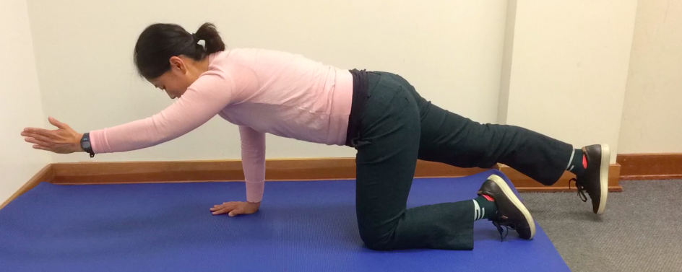 | Quadruped with Arm and Leg Extension (Progression)  Movement: First straighten leg and lift 2-3 inches, then straighten opposite arm making sure spine is straight and head is aligned with spine.  Dosage: Hold position for 5-15 seconds, repeat 3-5 times

Standing Stretches

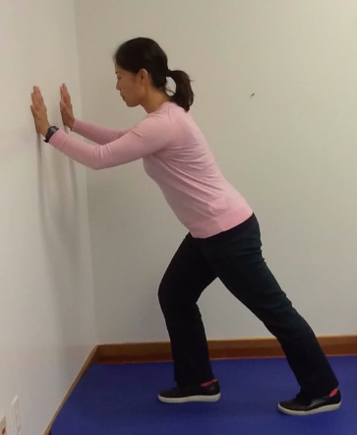 | Calf Stretch  Starting position: Face the wall and place one leg forward with knee bent. Lean into the wall and place the leg to be stretched back while maintaining a straight knee. Make sure your toes are facing the wall.  Movement: Slowly lean forward into the wall towards the front leg and stretch the calf (back of lower leg). (When the back knee is bent from a stretched position the stretch will be felt lower in the calf, more in the Achilles tendon). Do both stretches.  Dosage: Hold position for 5-15 seconds, repeat 3-5 times each
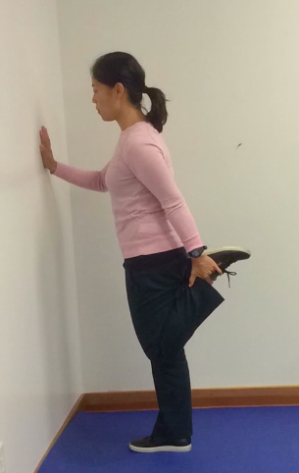 | Quadriceps or Stork Stretch  Hold on to the top of the foot or grab the pant leg. Make sure you have balance by holding onto the wall or a chair.  Movement: Gently pull heel towards buttock. Squeeze the buttocks and flatten spine (DO NOT arch the back). Feel the stretch in front of the thigh.  Dosage: Hold position for 5-15 seconds, repeat 3-5 times each
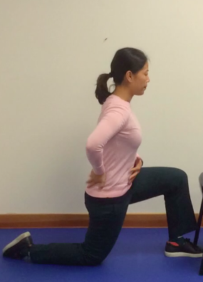 | Lunge/Kneeling Stretch  Movement: Place one foot forward in stride position about 2-3 feet apart and slowly lower body and drop the back knee towards the floor (may put a pillow or towel under knee). The front knee should stay above the foot. Make sure you have balance by holding onto the wall or a chair. Squeeze the buttocks and flatten spine (DO NOT arch the back).  Feel the stretch in front of the hip.  Dosage: Hold position for 5-15 seconds, repeat 3-5 times each

Standing Leg and Trunk Strengthening

Squats and lunges are important exercises to practice for correct body mechanics and to maintain neutral spine with lifting, pulling or pushing activities.

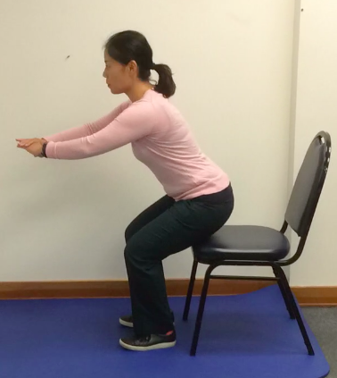 | Squats  Starting position: Place feet slightly wider than your hips and face away from chair  Movement: Slowly sit back towards chair (do not sit down) and come back up to standing  Dosage: Hold position for 5-15 seconds, repeat 5-15 times
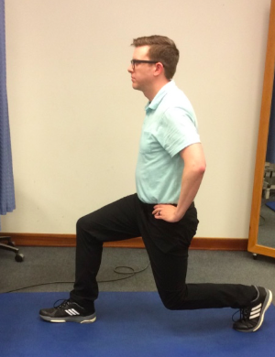 | Lunges  Starting position: Start in stride position, one leg in front of the other about 2-3 feet apart  Movement: Lower back knee towards floor, as above for the lunge stretch; however, do not place knee down on floor. Push back up to standing in stride position. Keep your spine upright, engage abdominal muscles, do not arch back. Switch legs.  Dosage: Hold position for 5-15 seconds, repeat 5-15 times each
In collaboration with University Health Services Physical Therapy Department

Campus Resources for:
- Ergonomics Website: https://uhs.berkeley.edu/facstaff/ergonomics/
- Link to video: https://www.youtube.com/watch?v=wbucdcsORrE
- Preventing Back Injuries: https://uhs.berkeley.edu/facstaff/ergonomics/back-injuries
- Active-at-Work: https://uhs.berkeley.edu/facstaff/wellness/active-at-work
- Healthy Campus: https://uhs.berkeley.edu/facstaff/wellness/healthy-campus

